Theory
Boolean algebra is a mathematical system used to represent and simplify logical expressions. It deals with two values: 0 (False) and 1 (True).
In digital electronics, Boolean expressions are implemented using logic gates such as AND, OR, and NOT gates. Boolean algebra laws are used to simplify a given expression into an equivalent expression with fewer terms and variables.
The main Boolean laws used are:
- Identity Law:
- Null Law:
- Complement Law:
- Idempotent Law:
- Distributive Law:
- Absorption Law:
- De Morgan's Law:
The simplified Boolean expression can then be implemented using logic gates and verified using a truth table.

Problem-1: F (A, B, C) = A̅BC + AB̅C + ABC̅ + ABC
The simplified expression: F=AB+BC
The circuit requires:
- 2 AND gates
- 1 OR gate

Input circuit:
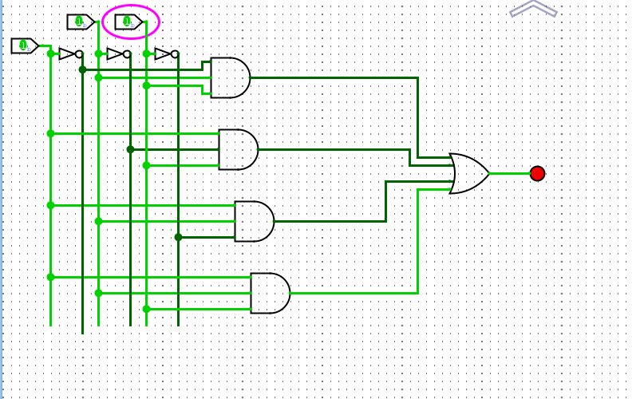
Output Circuit:
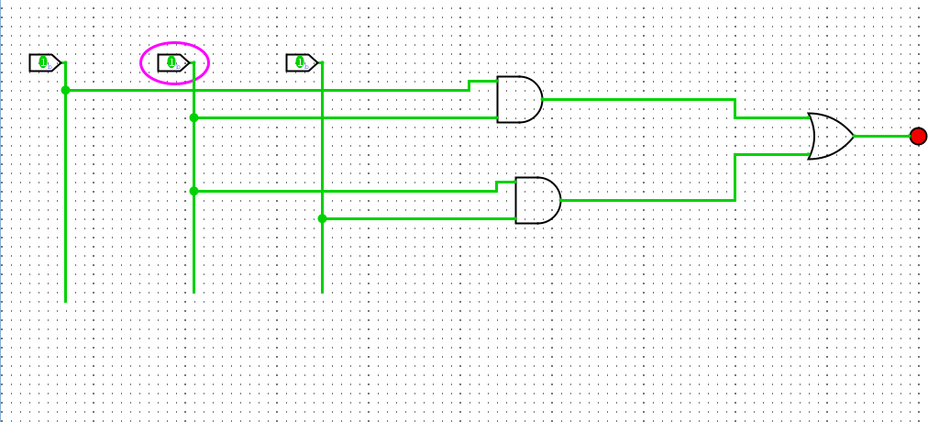

Problem-2: A(A+B) (A+B+C)
The simplified expression: F=A
Input Circuit:
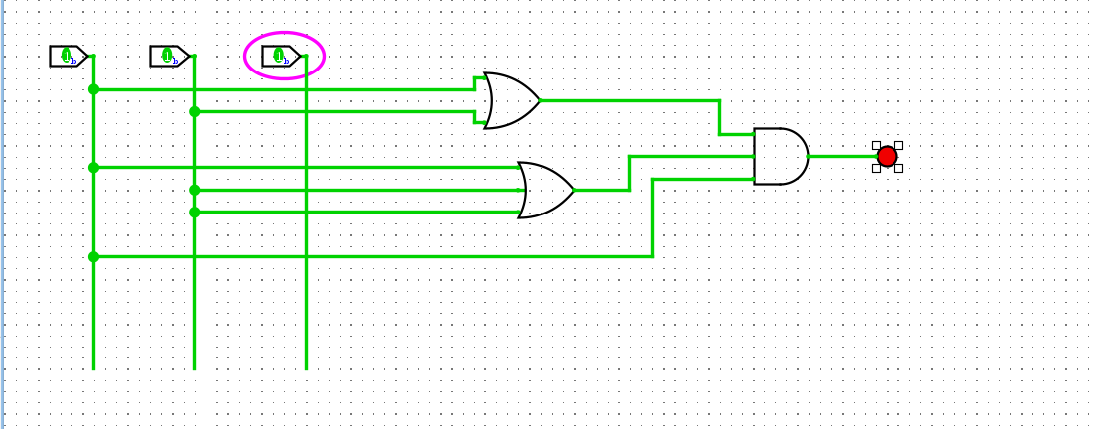

Output Circuit:
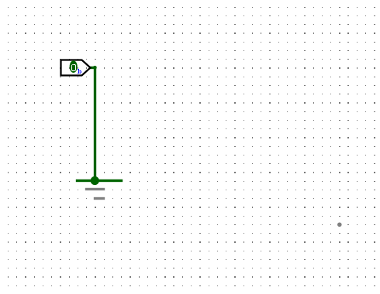

Problem-3: F (A, B, C) = (A+$\overline{BC}$ )(AB+ABC)
The simplified expression: F= 0
Input Circuit:
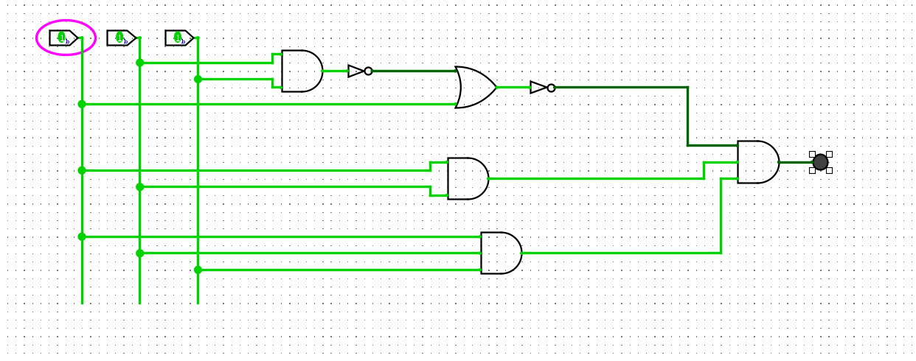
Output Circuit: 0
Problem-4: ($\overline{B}$ (A+B) +(A+B) (A+$\overline{B}$ )) $\overline{B}$
The simplified expression: F= A$\overline{B}$
The circuit requires:
- 1 AND gates
- 1 NOT gate

Input Circuit:
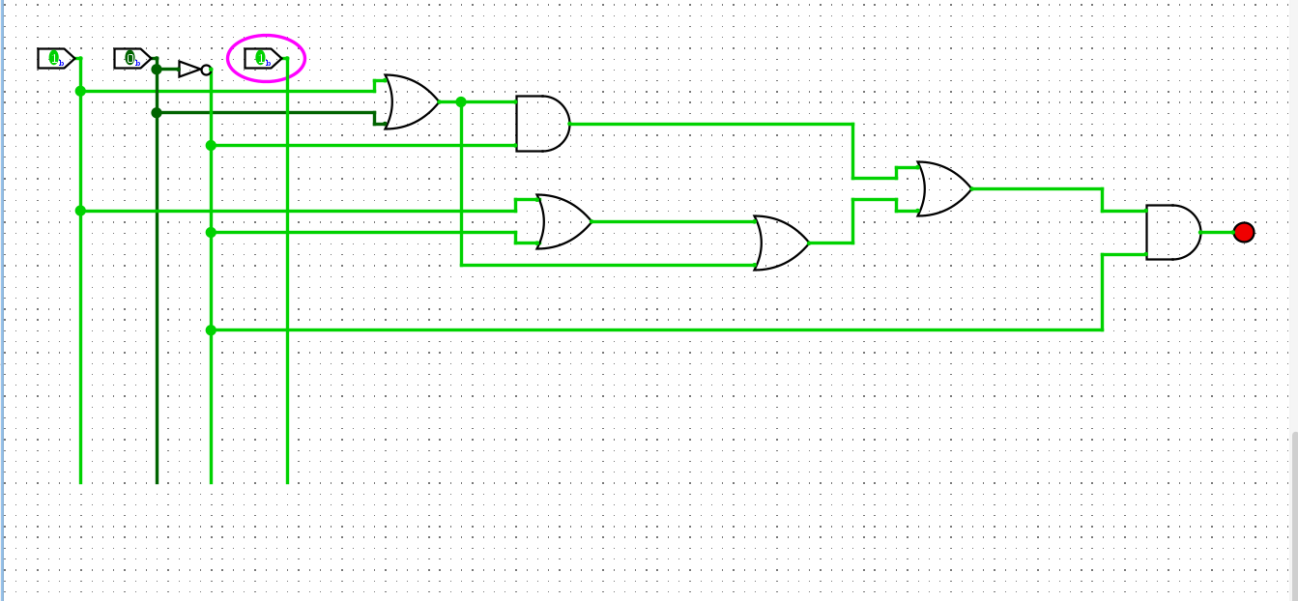

Output Circuit:
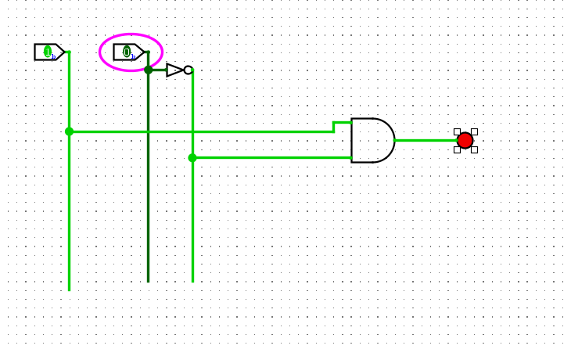
Conclusion:
The given Boolean expression was successfully simplified using Boolean algebra laws. The simplified expression requires fewer logic gates, which makes the circuit simpler and more efficient. The simplified expression was implemented using AND, OR gates, and the output can be verified using a truth table. Therefore, the experiment demonstrates the importance of Boolean algebra simplification in digital circuit design.

